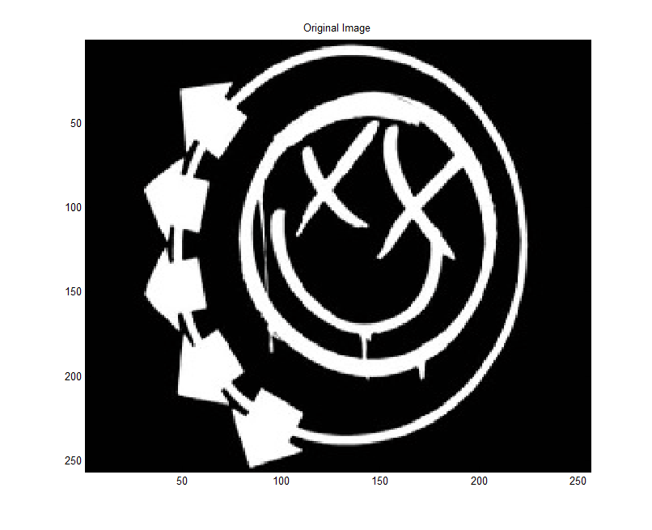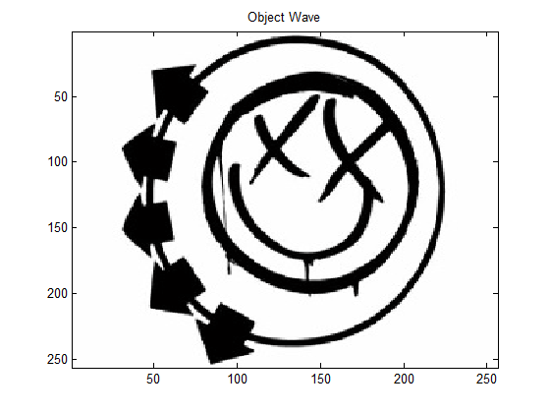

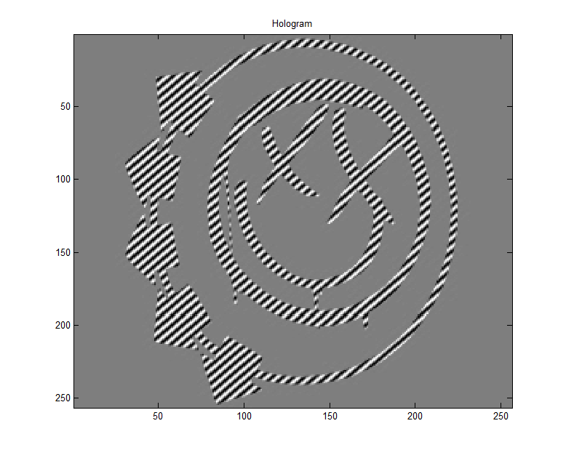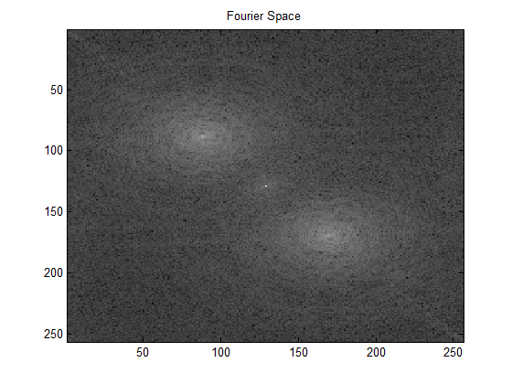

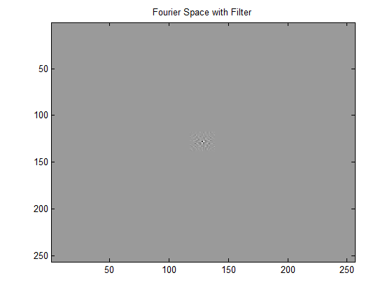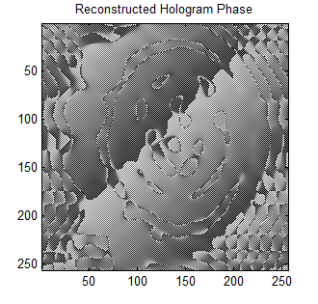

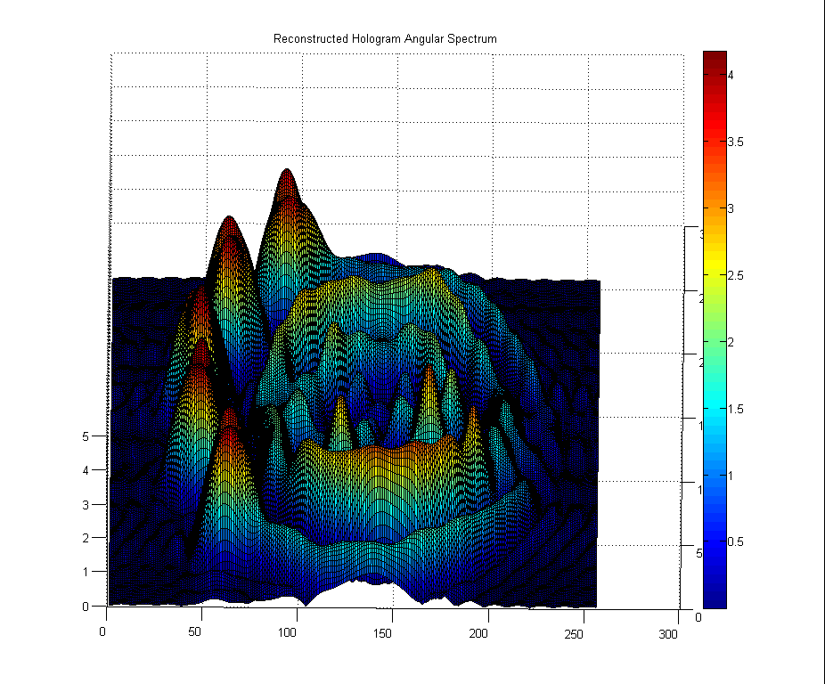

http://makeagif.com/i/gNUjl_

%Hologram and Reconstruction Simulation

%By: Joel Johnson

%------------------------------------------------------------------

%Simulate Object

Image = imread('smiley.jpg','jpg'); %imports image

Image = double(Image(:,:,1)); %assign image to an array

figure(1);

imagesc(Image);

colormap(gray(256));

title('Original Image');

[X,Y] = size(Image); %X and Y are sizes of the image

for x = 1:X;

for y = 1:Y;

if Image(x,y) < 1;

Image(x,y) = 5;

phi(x,y) = pi/2;

else Image(x,y) > 1;

phi(x,y) = pi;

end

end

end

z = 1e-6;

lambda = 633e-6;

%Phase Shift of Image

Objwave = abs(Image).*exp(1i.*phi) + (0.01*lambda)*rand(256);

figure(2);

imagesc(real(Objwave)); %displays real portion of image

colormap(gray(256));

title('Object Wave');

%Reference Wave

x = 1:1:X; %makes array

y = 1:1:Y; %makes array

[kx,ky] = meshgrid(x,y);

Referencewave = 2e5*exp(1i*(kx + ky)) + (0.01*lambda)*rand(256);

%Simulate Hologram

H = (abs(Objwave)).^2 + (abs(Referencewave)).^2 + (conj(Objwave).*Referencewave) + (conj(Referencewave).*Objwave);

Imax = max(max(H));

Ih = uint8(255*H/Imax);

FIh = (fftshift(fft2(Ih)));

figure(3);

imagesc(H);

colormap(gray(256));

title('Hologram');

figure(4);

imagesc(abs(log(FIh)));

colormap(gray(256));

title('Fourier Space');

%Simulate Fourier Mask

Cursorx = 88;

Cursory = 88;

filtersize = 10;

W = zeros(X,Y);

By = (Cursorx - filtersize:Cursorx + filtersize);

Bx = (Cursory - filtersize:Cursory + filtersize);

W(round(Bx),round(By)) = 1;

FIhfilter = FIh.*W;

Bx = (X/2) - Cursorx;

By = (Y/2) - Cursory;

FIhfilter2 = circshift(FIhfilter,[round(By),round(Bx)]);

figure(5); %centers around real term (top left)

imagesc(real(FIhfilter2));

colormap(gray(256));

title('Fourier Space with Filter');

%Hologram Reconstruction using the Angular Spectrum Method

k = 2*pi/lambda;

E(x,y) = exp(1i*z*sqrt((k).^2 - (kx.*ky) - (ky.*ky)));

E = (ifft2(FIhfilter2.*E));

figure(6);

surf(abs(E));

title('Reconstructed Hologram Angular Spectrum');

figure(7);

imagesc(angle(E));

colormap(gray(256));

title('Reconstructed Hologram Phase');